Configure Cacti VM after OVA Template Imported

*By Double.Lin 3/25/2024*

1. VM Template spec: CPU 8 cores, Memory 8GB, HD 100GB.   
   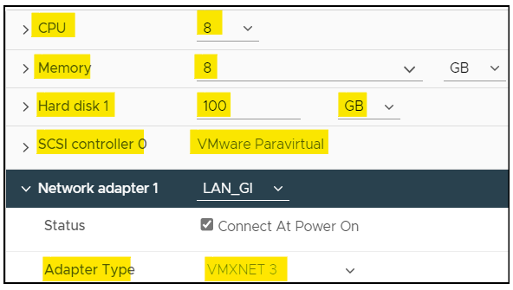
2. Download Cacti Template from OneDrive
   1. [Cacti_Template_v1.2.25](https://tpvtech3-my.sharepoint.com/:f:/g/personal/double_lin_tpv-tech_com/Emtoyexh_ThGnodGcHjMDEEBSS_-NpFMW7m0zB3ITazi0A?e=joY0rZ)
   2. PW is Cacti1.2.25
3. Import Template to vCenter as a Template
   1. Login vCenter =>Click VM Host -> Deploy OVF Template -> Local File -> Upload File to select OVA -> Next  
      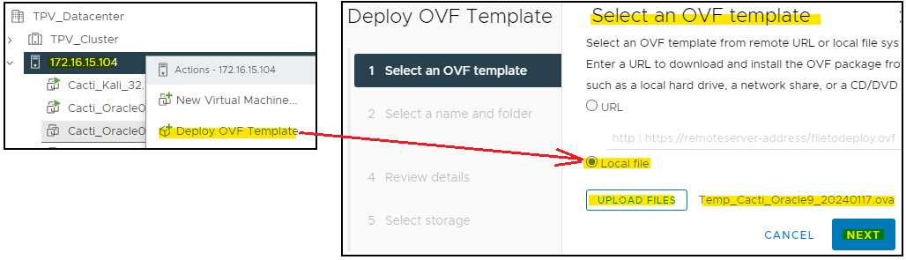
   2. Click Next  
      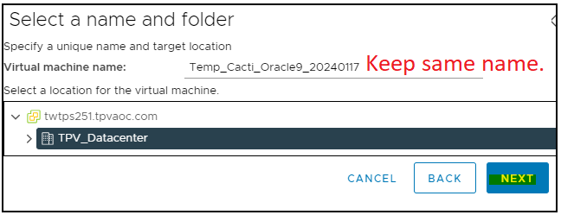
   3. Click Next (or change computer as required)  
      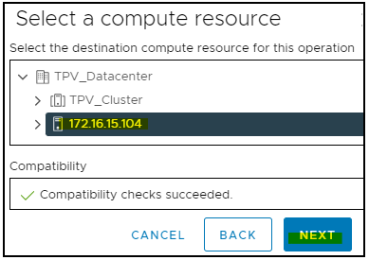
   4. Click Next  
      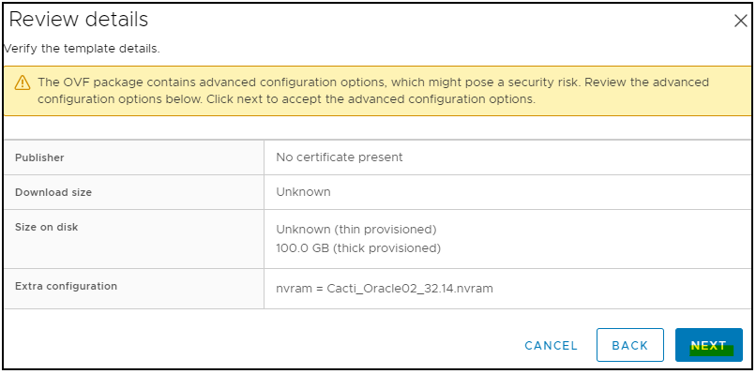
   5. Select Storage -> Next  
      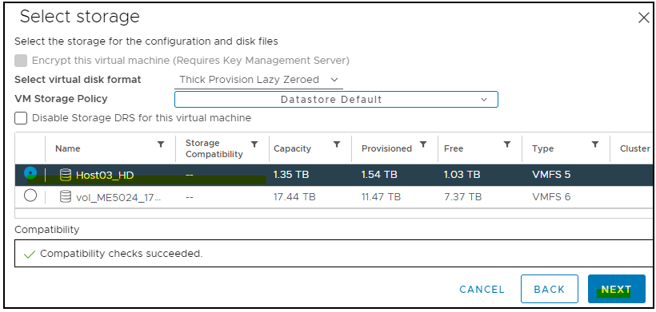
   6. Select Network => Next  
      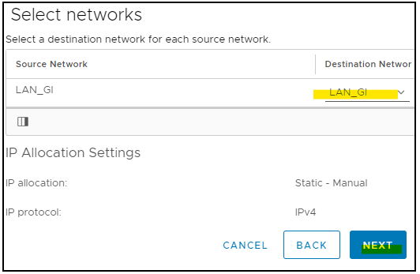
   7. Click Finish  
      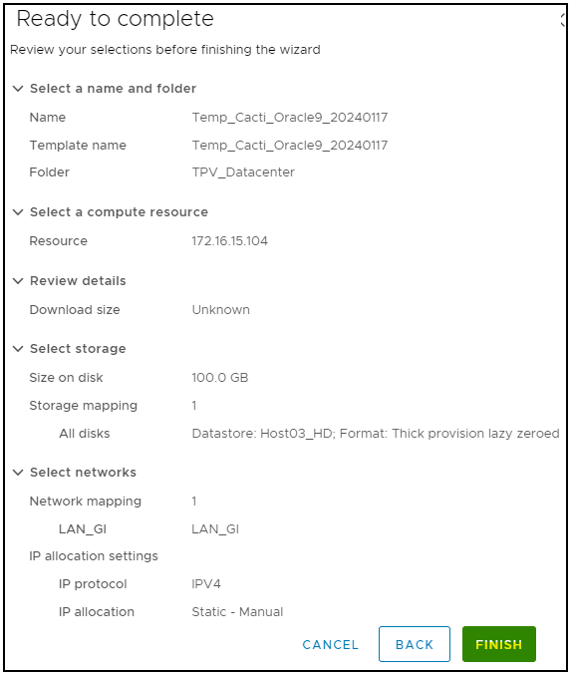
   8. Deployed on inventory list=> Click Template => Convert to Template  
      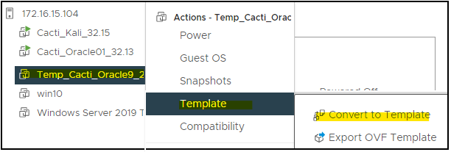
   9. Click Yes to Convert  
      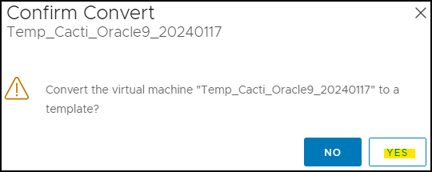
   10. Done of Cacti VM imported and convert to Template  
       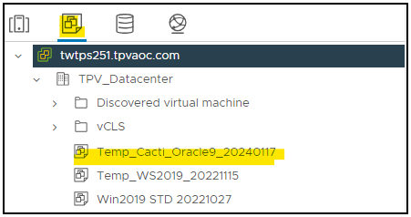
4. Deploy from Template
   1. Right Click Cacti Template => New VM from this Template  
      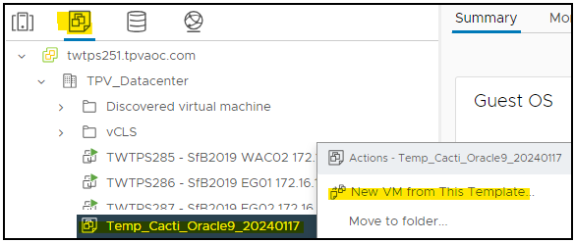
   2. Type Cacti host name => Next  
      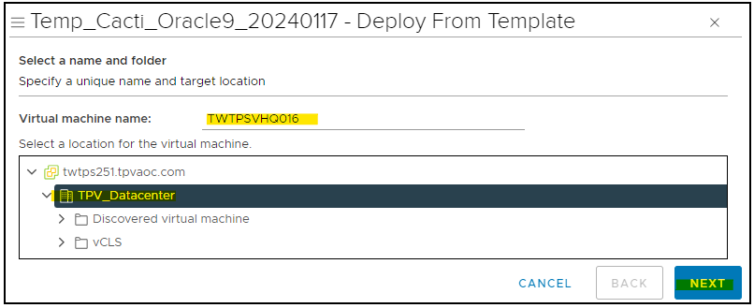
   3. Select VM Host.  
      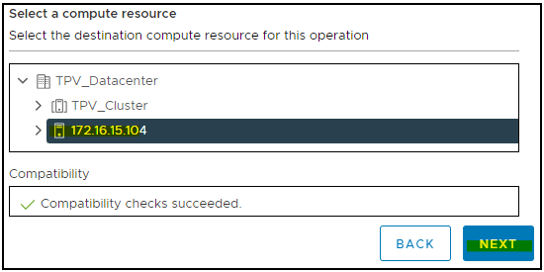
   4. Select Storage => 1.click a data store=>2. Select ”Thick Provision Lazy Zeroed”  
      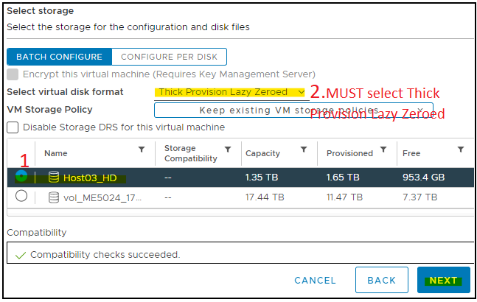
   5. Power on VM after creation => Next  
      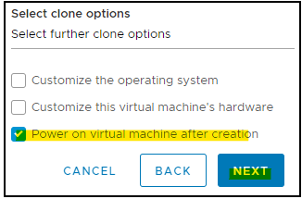
   6. Click Finish  
      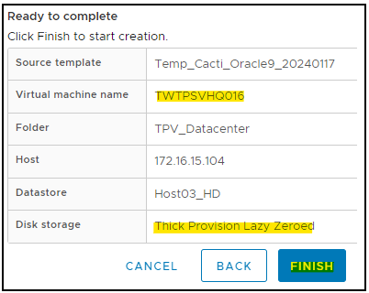
   7. Done
5. Configure VM
   1. Login as root
   2. Check current NIC’s UUIDnm  
      nmcli con show  
      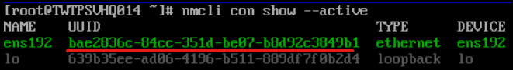
   3. Check current NIC’s MAC  
      ip address  
      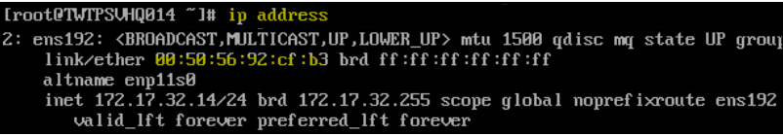
   4. Check Current NIC configuration  
      nmtui => Edit a connection =>Edit  
        
      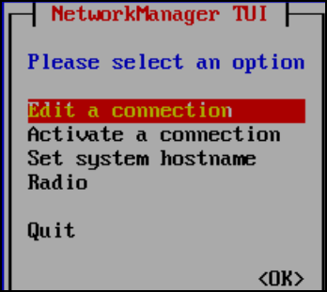 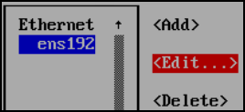
   5. Screenshot for re-create NIC reference => Cancel  
      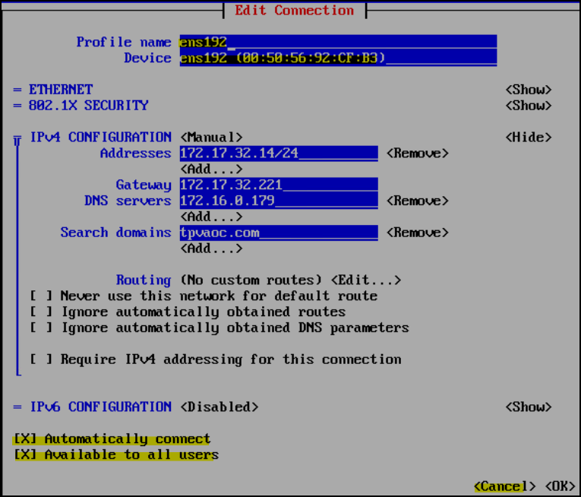
   6. Click ens192 => Delete =>Delete  
      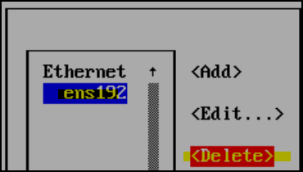 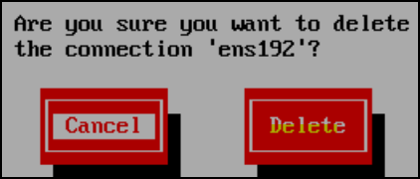
   7. Add => Ethernet => Create  
      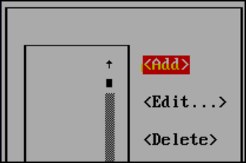 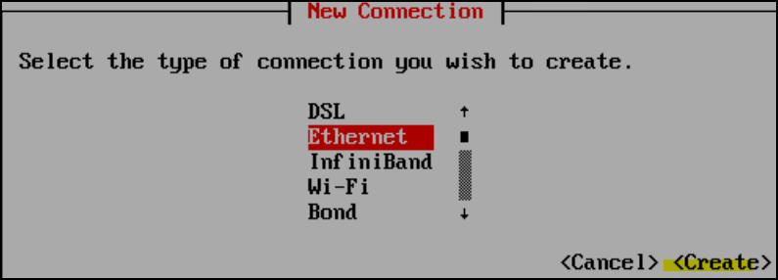
   8. Type information => OK  
      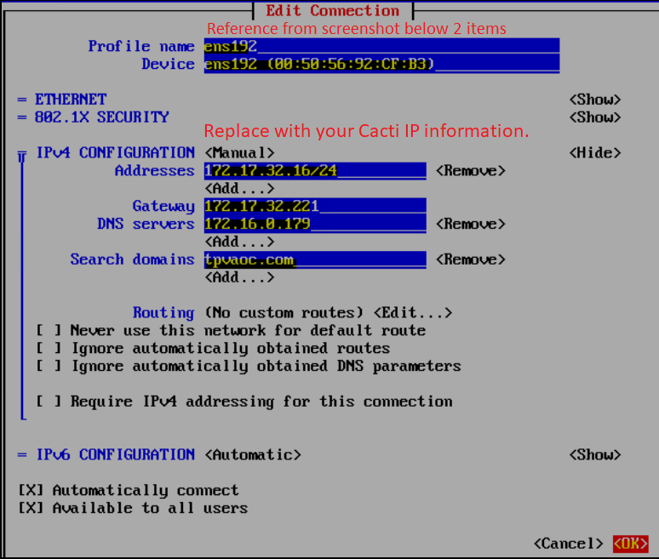
   9. Click “back  
      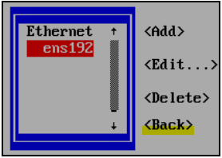
   10. Click Set hostname => type your host name => Ok  
       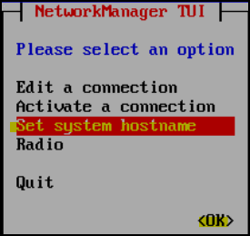 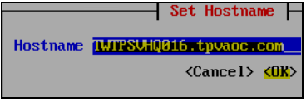 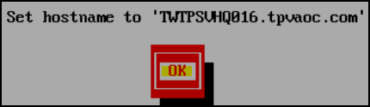
   11. Done => Click Quit  
       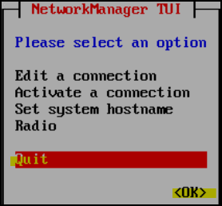
   12. nano /etc/hosts  
       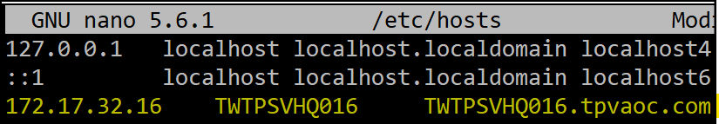
   13. Configure Time server to local DC

nano /etc/chrony.conf

#pool 2.pool.ntp.org iburst

pool **172.16.0.179** iburst

pool **172.16.0.178** iburst  
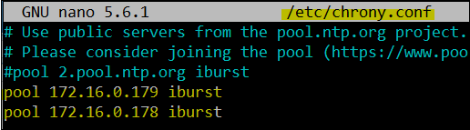

* 1. Reboot now  
     
  2. Verify UUID is different with previous now.   
     nmcli con show  
     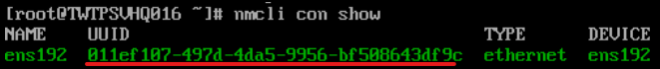  
     Previous is   
     
  3. Test Network connection is fine  
     Ping [www.cisco.com](http://www.cisco.com)  
     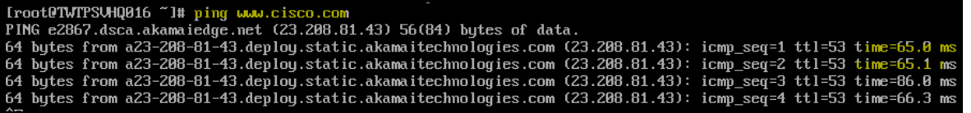

1. Re-verify OS related.
   1. Check DNS is local DC  
      nano /etc/resolv.conf  
      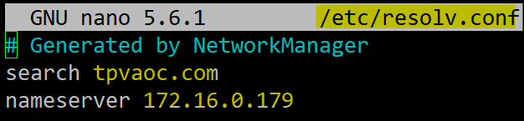
   2. Change HostName  
      hostname  
      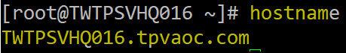
2. Setting time zone
   1. Review the current system date and time configuration:  
      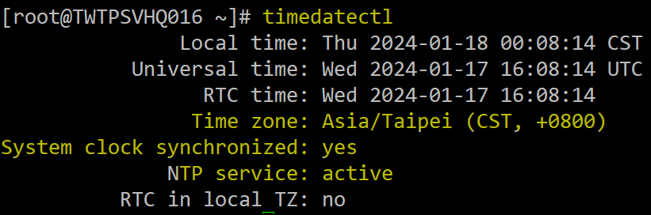
   2. List all system time zones. Press the q key to exit:  
      timedatectl list-timezones  
      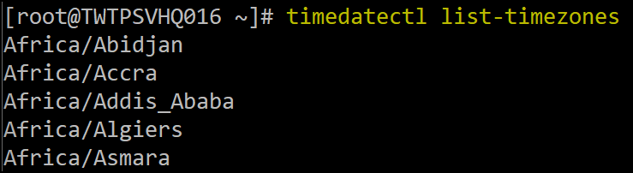
   3. Search for your time zone, using underscores for compound names. For example, to find Pacific Daylight Time (PDT):  
      timedatectl list-timezones | grep 'Sao_Paulo'  
      
   4. Set your time zone:  
      timedatectl set-timezone America/Sao_Paulo  
      
   5. Verify new time zone is changed  
      timedatectl  
      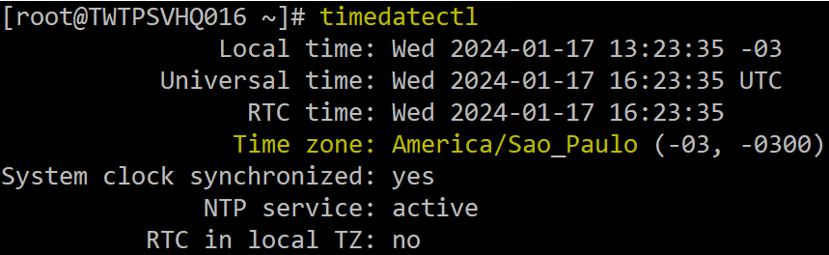
3. Configure Time Server to local DC
   1. nano /etc/chrony.conf  
      #pool 2.pool.ntp.org iburst

pool 172.16.0.179 iburst

pool 172.16.0.178 iburst

* 1. systemctl restart chronyd

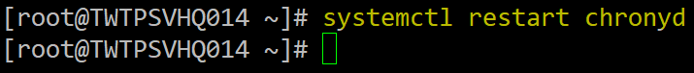

* 1. systemctl status chronyd (verify selected source IP is switch to local DC now)  
     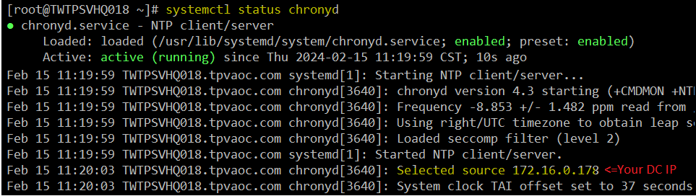
  2. (Optional-Troubleshooting) Reboot now if Selected Ssource IP still not change to your local DC.  
     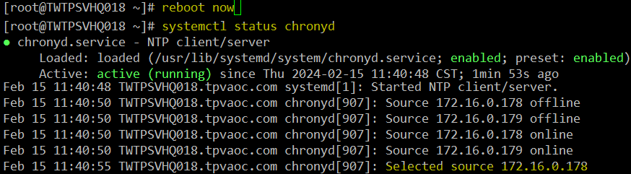
  3. Browse <https://time.is> and command date to compare time is same.  
     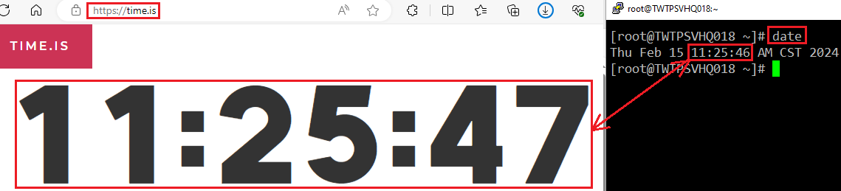

1. Regenerate CA.
   1. openssl req -x509 -nodes -days 3650 -newkey rsa:2048 -keyout /etc/ca/cacti.key -out /etc/ca/cacti.crt  
      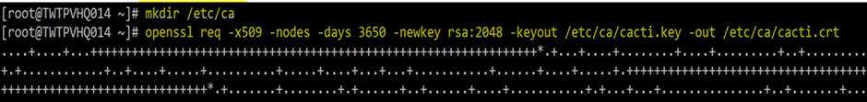  
      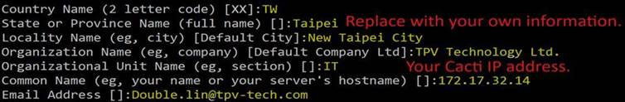
   2. ls -lh /etc/ca  (check time stamp is now)  
      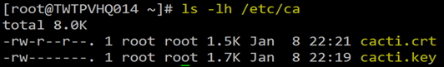
   3. systemctl restart httpd  
      cid:image027.png@01DA5908.5964CE40
   4. Check CA IP is map to your new Cacti  
      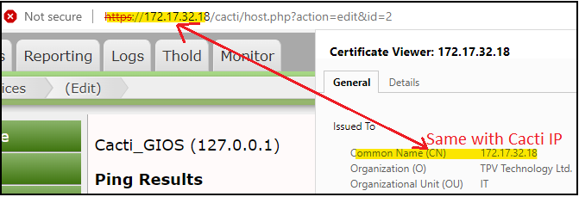
2. Modify Cacti related
   1. nano /etc/php.ini  
      date.timezone = America/Sao_Paulo  
      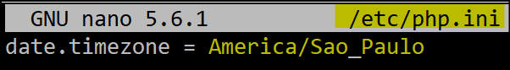
   2. Change Mail/DNS on Web console.  
      Add your Cacti IP into “Exchange AP relay allow IP” list.  
      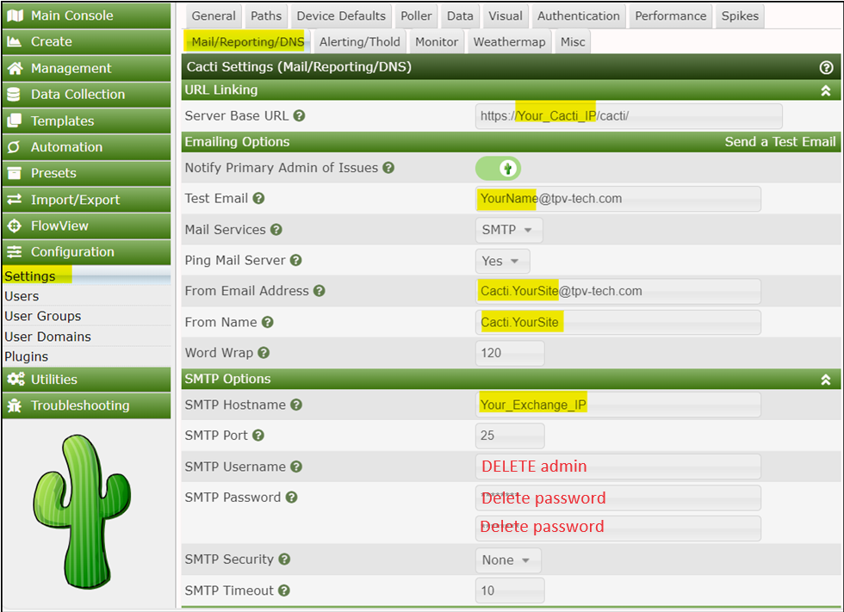  
      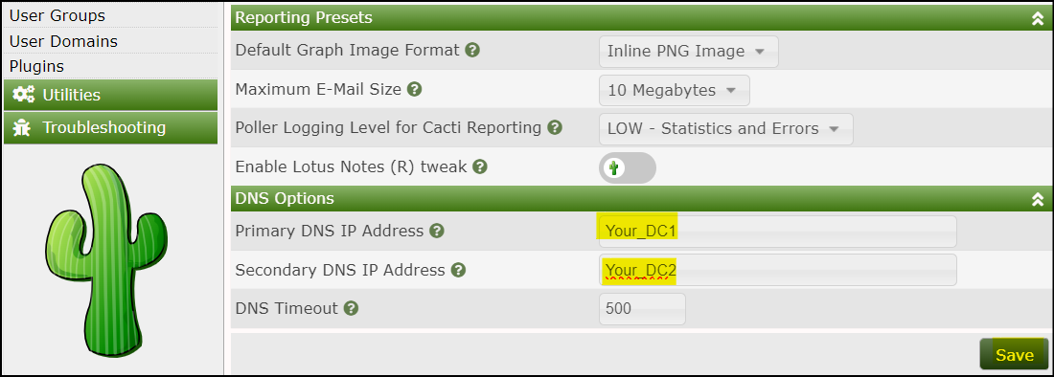
   3. Change Thresholds  
      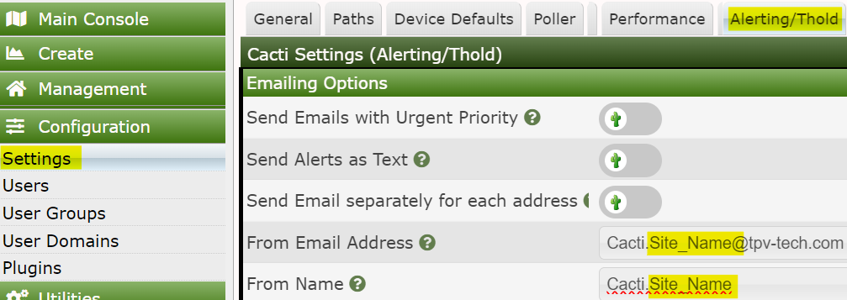  
      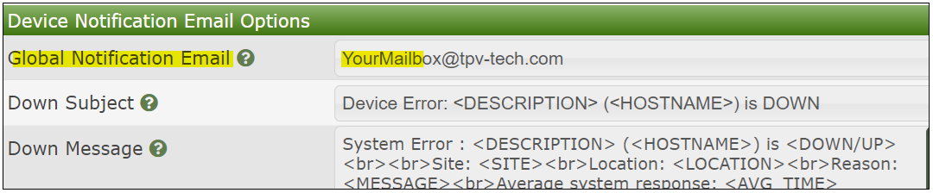
   4. Modify Data Collectors   
      